

NOVAC TECHNOLOGY SOLUTIONS

User Manual

Document Version No.: 1.00

Revision History
Version No | Reason For Changes | Author | Approver
0.01 | Draft | ANURAG KUMAR
1.00 | Reviewed & Approved the User Manual | ANURAG KUMAR

Table of Contents
1. Introduction 4
2. Changes in the Fire endorsement template for Prorata 4

Introduction

As per the requirement, The system is expected to generate the financial endorsement output according to the provided format for prorate calculation type.
- Guidelines, circulars, instructions and directions released from time to time by Philippines Insurance council.

Changes in the Fire endorsement template for Prorata
The system is required to generate or print the endorsement output as given format for prorate calculation type for listed endorsements
1. INCLUSION OF EARTHQUAKE (WITH ADDITIONAL PREMIUM)
2. INCLUSION OF TYPHOON/ FLOOD COVERAGE (WITH ADDITIONAL PREMIUM)
3. INCLUSION OF TYPHOON COVERAGE (WITH ADDITIONAL PREMIUM)
4. INCLUSION OF VOLCANIC ERUPTION COVERAGE (WITH ADDITIONAL PREMIUM)
5. INCLUSION OF EXTENDED COVERAGE (WITH ADDITIONAL PREMIUM)
6. INCLUSION OF RIOT, STRIKE AND MALICIOUS DAMAGE (WITH ADDITIONAL PREMIUM)
7. DELETION OF EARTHQUAKE (RETURN PREMIUM)
8. DELETION OF TYPHOON/ FLOOD (RETURN PREMIUM)
9. DELETION OF TYPHOON (RETURN PREMIUM)
10. DELETION OF VOLCANIC ERUPTION (RETURN PREMIUM)
11. DELETION OF EXTENDED COVERAGE (RETURN PREMIUM)
12. DELETION OF RIOT, STRIKE AND MALICIOUS DAMAGE (RETURN PREMIUM)
13. INCLUSION OF ADDITIONAL LOCATIONS
14. DELETION OF EXISTING LOCATIONS
15. INCLUSION OF BUILDING/S
16. INCLUSION OF MACHINERY AND EQUIPMENT
17. INCLUSION OF STOCKS
18. INCLUSION OF CONTENTS
19. INCLUSION OF FURNITURE, FIXTURE AND FITTINGS
20. INCLUSION OF LOSS OF RENT
21. INCLUSION OF ALTERNATIVE ACCOMMODATIONS
22. DELETION OF BUILDING/S
23. DELETION OF MACHINERY AND EQUIPMENT
24. DELETION OF STOCKS
25. DELETION OF CONTENTS
26. DELETION OF FURNITURE, FIXTURE AND FITTINGS
27. DELETION OF LOSS OF RENT
28. DELETION OF ALTERNATIVE ACCOMMODATIONS
29. INCREASE IN SUM INSURED
30. DECREASE IN SUM INSURED
31. INCLUSION OF EXTENSION COVER (WITH ADDITIONAL PREMIUM)
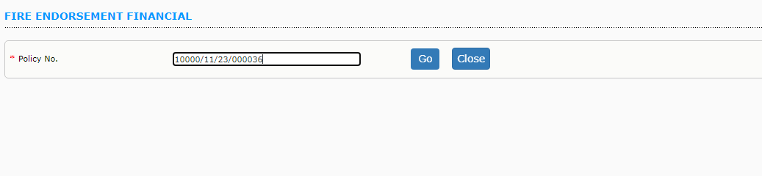
User has to enter the policy Number and click on Go button.
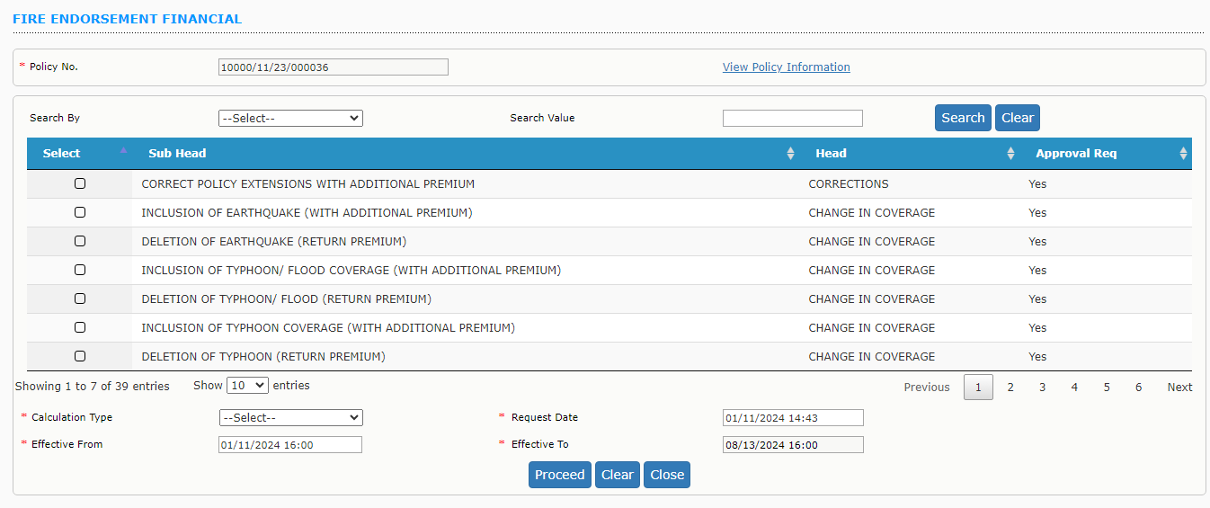
System will display the list of financial endorsements. Select the endorsement and in Calculation Type if user select Pro Rata System will calculate the premium value based on that and it will generate the endorsement schedule in new format. Remaining endorsement flow is same as existing.

